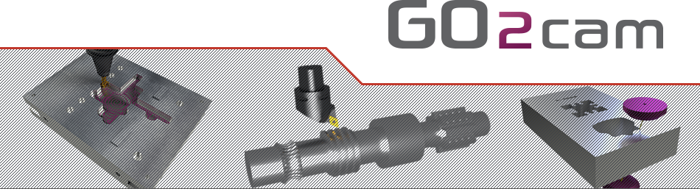

Nakamura Tome WY-150

The contents of this manual are relative to GO2cam version:

**V6.09**

**Sptember 2023**

**About GO2cam**

All information contained in this document can be modified without prior notice. Unless specified, the companies, the names and data used in the examples are unreal. Any part of this manual cannot be reproduced or transmitted for any purpose or by any means without a written permission of GO2cam International.

Copyright © 2009-2021 GO2cam International. All rights reserved.

Portions of this software are protected by copyright and are own by © Siemens Product Lifecycle Management Software Inc.

Portions of this software are protected by copyright and are own by © Datakit.

Portions of this software are protected by copyright and are own by © MachineWorks Ltd.

Portions of this software are protected by copyright and are own by © Open Design Alliance.

Portions of this software are protected by copyright and are own by © ModuleWorks GmbH.

**Warning to the user:** all the forms included in this document are given as examples only.   
GO2cam International cannot be responsible for any consequences of their use.

Summary

1 Machine description 3

2 Package parameters 4

2.1 Tool offset number management 4

2.2 Use Dat file 5

2.3 Use G411 output (JUMP option) 8

2.4 Origin Option 8

# Machine description

The machine is Nakamura Tome WY-150 with two spindles and 2 turrets. One upper, and one lower.

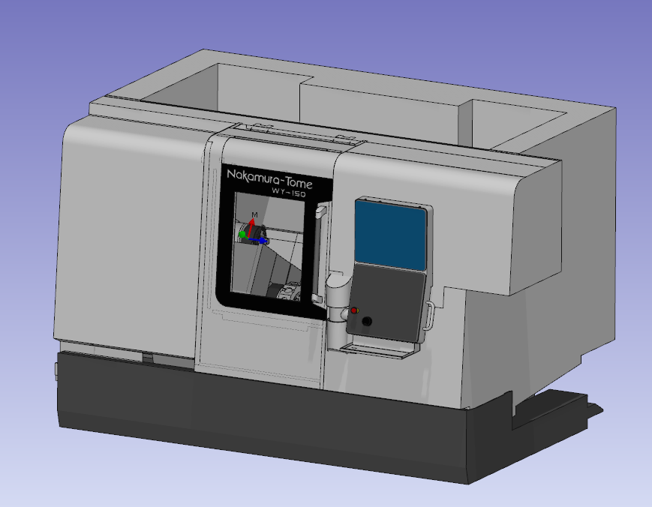

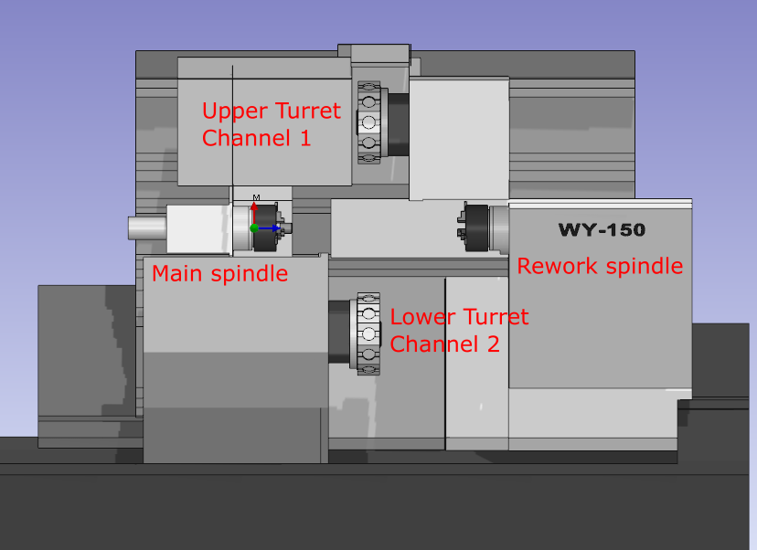

# Package parameters

## Tool offset number management

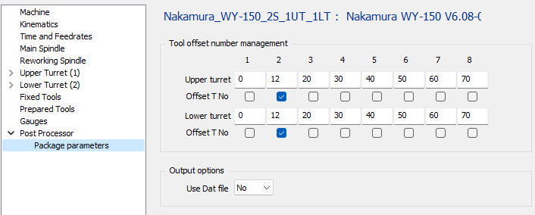

By default a tool is called with it number and offset number with the same than the tool number.

If the tool mounted on the tool support 1 of a turret, it will called with T0101.

If there is more than one tool the second tool mount on the second position will be offset of 12. The tool will be called with T0113.

You can also check the “Offset T No” to be able to offset the tool number too.

If the option is check the tool number will be offset of 12. It will be called with T1313.

You can change the offset value for each tool position. By default the first triedrial of tool holder will offset of 0, the second offset of 10, the third offest of 20, …

## Use Dat file

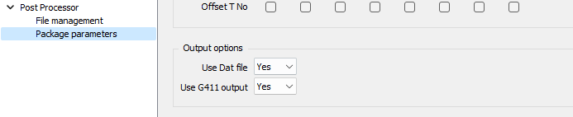

If you use this mode it means the parting rework operation will not be outputed by PP and have to be manage in the dat file. It means also the user will always work in bar and always use the same scenario in GO2cam.

This file has to be saved in the mac folder with the same name than MCT file and “.DAT” as extension.

An empty file with only section defined is stored in the mac folder with the name of MCT following by “_Empty”.

You can define several Dat files with these rules for the name :

* File name start with the name of machine
* Add a suffix to the name of dat file
* Don’t use “-“ in the suffix

Sample : “Nakamura_WY-150_2S_1UT_1LT_Sample.DAT” and “Nakamura_WY-150_2S_1UT_1LT_Empty.DAT”

You will have the list in the PP launch window at start, to choose which one use.

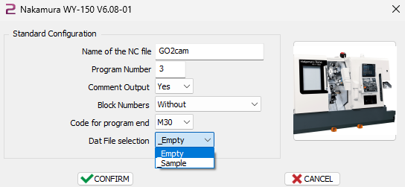

A dat file contains preformat NC code and you can use some variables that will be replaced by values when the program will be generated.

The available variables are the following

|  |  |  |
| --- | --- | --- |
| **Variable** | **Meaning** |  |
| $PART_LG | Length of finish part |  |
| $STOCK_LG | Length of stock |  |
| $STOCK_ZMAX | Zmax of stock regarding the origin |  |
| $STOCK_DIAM | Diameter of stock |  |
| $STOCK_DIAM_IN | Inside diameter of stock |  |
| $Z_ALLOWANCE | Allowance of the stock regarding the origin |  |
| $MAIN_OUT | Length of part out of the main spindle |  |
| $REWORK_IN | Length of part inside the chuck from the max of chuck in rework spindle |  |
| $REWORK_OUT | Length of part out of the chuck in rework spindle |  |
| $CUT_PART_LG | Length of part after parting |  |
| $CUT_Z_ALLOWANCE | Allowance in the aprting cycle |  |
| $CUT_UNIT | Spindle unit code 97 for rot/min 96 for m/min |  |
| $CUT_CSS | Cutting speed for parting operation. 0 if unit is 97 |  |
| $CUT_RPM | Spindle speed in rotation per minute. 0 if unit is 96 |  |
| $CUT_TYPE | Type of parting cycle used  0 : Simple  1 : Deburring  2 : Chip Breaking  3 : Mixt |  |
| $CUT_DEBURRING_DEPTH |  |  |
| $CUT_CHIP_BREAK_DEPTH |  |  |
| $CUT_CHIP_BREAK_RETRACT |  |  |
| $NUM_PROG | Number of program |  |
| $REWORK_PART_CATCHER | Position of part catcher | By default the value is set to -120  It can be change by using techno function “Part removal” |

## Use G411 output (JUMP option)



When using G411, the PP will output a G411 command at the start of operation. For main spindle it will output G411 L1 I<xx> and for rework spindle G411 R1 I<xx> where <xx> is the block number of the end of operation.

If this option is used it will not have any other block number in the program.

The other statements of G411 have to be output with the DAT file. Check the machine manual to have more information about it.

## Origin Option

It’s possible to define a default value for origin number for main spindle and for rework spindle.

